**Automation Testing Report for buffalo burger** **Web** **Application**

**Date and Time:** September 3, 2024, 16:00 PM - 12:00 AM

**Tester(s):** Mohamed Mamdouh El Nomrosy (Junior QA Tester)

**Duration:** 8 hours

**Test Environment:**

* **Environment Details:**
  + Browser: Google Chrome Version🡺128.0.0.0
  + Operating System: Windows 10
  + Buffalo Burger Web Application
  + Network: Wi-Fi, Mobile Data
* **Tools Used:**
  + Browser Developer Tools
  + Cypress
  + Screen Recording Software

**Testing Objectives:**

* **Scope:**
  + Test login functionality with incorrect and correct phone numbers and passwords.
  + Verify interactions with the Offers page and the process of adding items to the cart.
  + Validate the checkout process and address details entry.
* **Focus:**
  + Ensure proper handling of login scenarios with incorrect and correct credentials.
  + Confirm the correct operation of selecting items from offers, adding them to the cart, and completing the checkout process.
  + Verify accurate address details entry and delivery time selection.

**Test Approach:**

* **Exploration Strategy:**
  + Execute tests based on user scenarios focusing on essential workflows and edge cases.
  + Perform exploratory actions to uncover potential issues.
  + Use Cypress to automate critical test cases for consistency and accuracy.
* **Techniques Used:**
  + Boundary value analysis for form inputs
  + Error guessing during the checkout process
  + Black Box end to-end Testing for UI

**Automated Test Cases and Results:**

1. **Login Page with Incorrect Phone Number & Incorrect Password**
   * **Description:** Validate error handling when entering incorrect phone number and password.
   * **Test Steps:**
     + Navigate to the login page.
     + Enter an incorrect phone number (01118712584) and password (gskgkaslaal).
     + Submit the login form.
   * **Expected Result:** An error message "Mobile number not found" should be displayed.
   * **Actual Result:** The error message was displayed as expected.
   * **Code:**

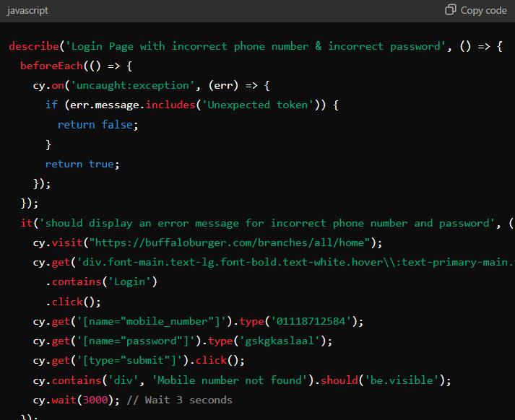

**2.Login Page with Correct Phone Number & Incorrect Password**

* **Description:** Validate error handling when entering a correct phone number and incorrect password.
* **Test Steps:**
  + Navigate to the login page.
  + Enter a correct phone number (01118712681) and an incorrect password (gskgkaslaal).
  + Submit the login form.
* **Expected Result:** An error message "Wrong password" should be displayed.
* **Actual Result:** The error message was displayed as expected.
* **Code:**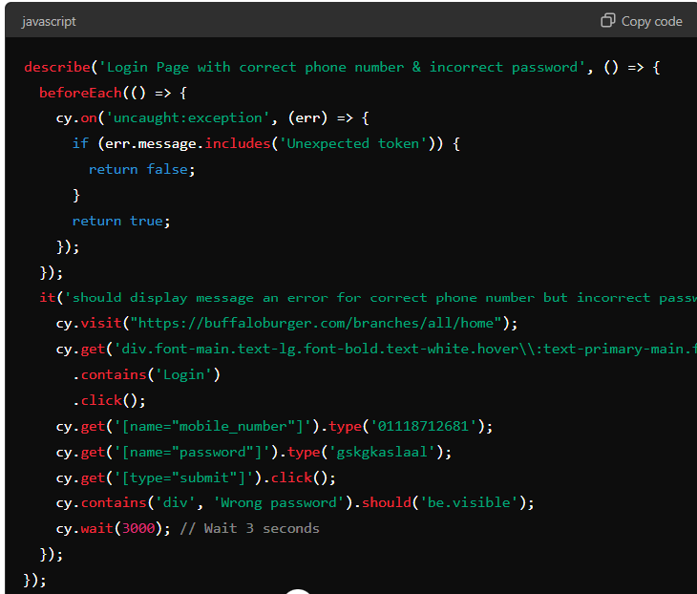

**3.Login Page with Incorrect Phone Number & Correct Password**

* **Description:** Validate error handling when entering an incorrect phone number and correct password.
* **Test Steps:**
  + Navigate to the login page.
  + Enter an incorrect phone number (01118712684) and correct password (Mohamed@123).
  + Submit the login form.
* **Expected Result:** An error message "Mobile number not found" should be displayed.
* **Actual Result:** The error message was displayed as expected.
* **Code:**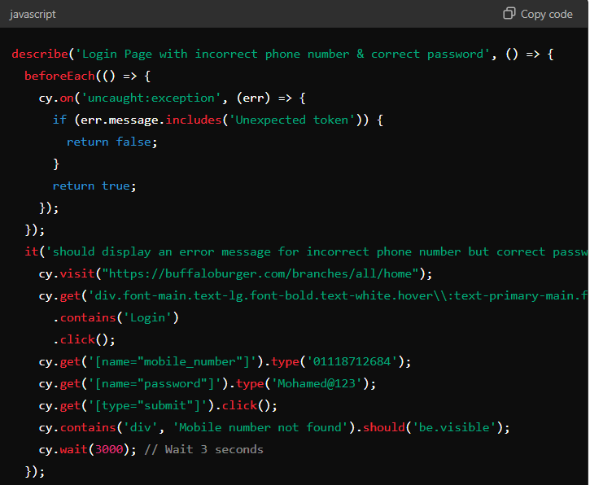

**4.Login Page with Correct Phone Number & Password**

* **Description:** Validate successful login with correct phone number and password.
* **Test Steps:**
  + Navigate to the login page.
  + Enter a correct phone number (01118712681) and password (Mohamed@123).
  + Submit the login form.
* **Expected Result:** The URL should include /home, indicating a successful login.
* **Actual Result:** The URL included /home, and the login was successful.
* **Code:**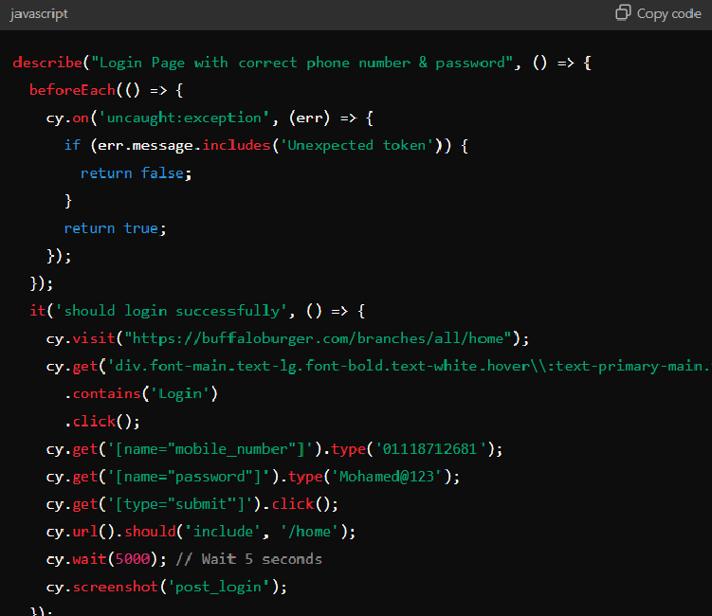

**5.Login, Select Two Sandwiches & Meal Offer from Offers Button**

* **Description:** Verify the process of selecting items from offers, adding them to the cart, and completing checkout.
* **Test Steps:**
  + Navigate to the login page.
  + Log in with valid credentials (01118712681 and Mohamed@123).
  + Navigate to the Offers page.
  + Select and add two sandwich items and a meal offer to the cart.
  + Proceed to checkout and enter address details.
* **Expected Result:** Items should be added to the cart, and checkout should be completed successfully with correct address details.
* **Actual Result:** Items were added to the cart, and checkout was completed with correct details.
* **Code:**

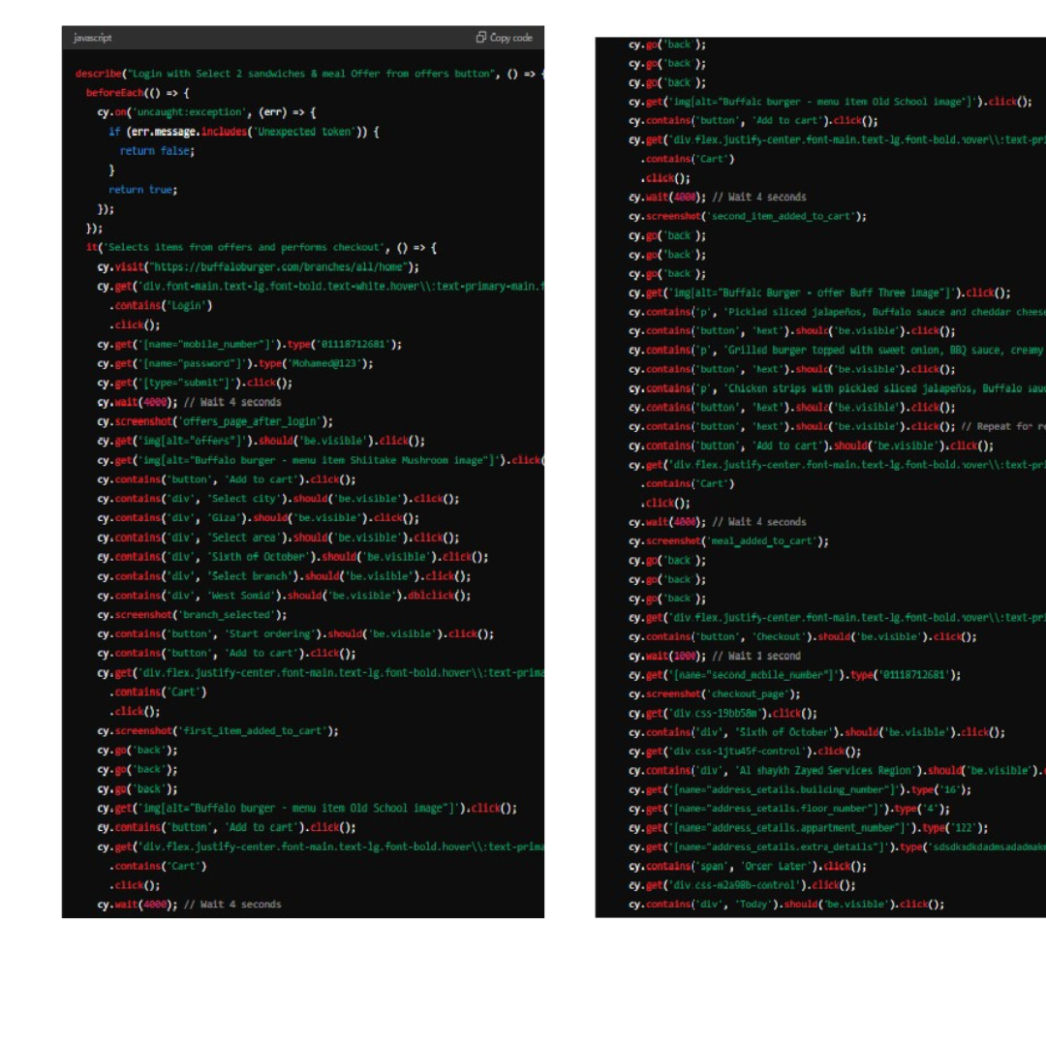

**Notes:**

* **Bugs Found:** No significant bugs were identified during this Automation testing phase.
* **Recommendations:**
  + Ensure consistent UI elements' visibility and interaction states across different test scenarios.
  + Validate edge cases for various user inputs to strengthen error handling.

**Attachments:**

* Screenshots of various stages and results as captured during the testing process.